**PURBANCHAL UNIVERSITY**



**DEPARTMENT OF COMPUTER ENGINEERING**

**KHWOPA ENGINEERING COLLEGE  
LIBALI-2, BHAKTAPUR**

**A PROJECT REPORT**

**ON**

**HAMRO GAS**

Project work submitted in partial fulfillment of requirements for the award of the degree of Bachelor of Engineering in Computer Engineering (Fifth Semester)

**SUBMITTED BY**

1. Aman Mool (740303)

2. Jenish Prajapati (740317)

3. Manish Hyongoju (740321)

4. Manisha Gora (740322)

**UNDER THE GUIDANCE OF**

Er. Shiva Prasad Mahato

12 November,2020

# ACKNOWLEDGEMENT

First of all we would like to express our sincere thanks to the department of Computer Engineering for providing us the opportunity to explore our interest and ideas in the engineering field through the project.

We grant sense of gratitude to Mrs. Reena Manandhar as well as all member of Head of Department of Computer Engineering for their encouragement, inspiration and guidance for accomplishing this valuable task.

Our sincere thanks goes to all the teachers, our parents and friends who helped and supported us throughout the project.

Finally, we would like to thank our supervisor **Er. Shiva Prasad Mahato**  who helped us a lot in gathering different information, collecting data and guiding us from time to time and sharing us their valuable ideas in selecting project title as “**Hamro Gas**” despite of their busy schedules.

**Group Members**

1. Aman Mool (740303)
2. Jenish Prajapati (740317)
3. Manish Hyongoju (740321)
4. Manisha Gora (740322)

# ABSTRACT

This online Gas booking system is a web based system that provides an easy user interface so that users can easily book the gas in advance without going to the store itself. The system is divided into different modules where there are number of users. User may be a visitor and in that case they can view the gases. In order to book the gases, they must click on the gas they want and must fulfill the verification protocol send via mail. Admin users can manage details of orders, users, delivery, expenses. Thus, this web based system is able to make an advance booking and prevent people from saving the valuable time by not having to go in store and be in a queue to get gases.

# TABLE OF CONTENTS

ACKNOWLEDGEMENT i

ABSTRACT ii

TABLE OF CONTENTS iii

LIST OF FIGURES v

CHAPTER 1 1

INTRODUCTION 1

1.1 Background: 1

1.2 Statement of Problem: 1

1.3 Objectives: 1

1.4 Scopes: 1

CHAPTER 2 2

LITERATURE REVIEW 2

CHAPTER 3 3

METHODOLOGY 3

3.1 Background: 3

3.2 Block Diagram 3

3.3 E-R Diagram 4

3.4 Tools and Platforms 4

CHAPTER 4 5

RESULT AND DISCUSSION 5

4.1 Results and Features 5

4.1.1 Screenshots 5

4.1.1.1 Frontend 5

4.1.1.4 Backend 13

CHAPTER 5 17

CONCLUSION AND RECOMMENDATION 17

5.1 Conclusion 17

5.2 Future Recommendation 17

REFERENCES 18

## LIST OF FIGURES

|  |  |  |
| --- | --- | --- |
| **Figures** | **Title** | **Page** |
| 3.1  3.2  4.1  4.2  4.3  4.4  4.5  4.6  4.7  4.8  4.9  4.10  4.11  4.12  4.13  4.14  4.15  4.16  4.17  4.18  4.19  4.20  4.21 | Block diagram of Hamro Gas  ER Diagram of Hamro Gas  Index page  Google Map  Banner page  Contact page  Recover page  Login Page  Gas Display  Gas Description  Review Page  Dark mode  Checkout Form  Verification Code  Shipping Details  Dashboard  Charts  Add Delivery Staff  Manage Delivery Staff  Manage Map  List of orders  Delivery location map  List of Stoves | 3  4  5  6  6  7  7  7  8  8  9  10  10  11  12  13  13  14  14  15  15  16  16 |

# CHAPTER 1

## INTRODUCTION

### 1.1 Background:

Using LPG gases has been one of the most used resource for different purposes whether it be for household or other purpose. According to National Population and Housing Census 2011, about 21.03 percent households use LPG. In urban areas, more than two-third, or 67.68 percent, of the households use LPG for cooking. This rises problems like having to sit in queue for long period of time. In order to solve this problem, we decided to work on the system that helps us to manage this problem.

This project “Hamro Gas” allows clients to book the Gas in advance and get their Gas delivered. This system also allows the agency maintain the records of the consumers, booking details in more systematic and advanced manner. This system serves well for both customers and agency helping agency to maintain record and avoiding customers the hassle-free booking. In general, the main purpose of this project is to provide a hassle-free booking of gas that helps both the consumer and agency.

The System is with PHP configuration and MySQL Database. Here this project is implemented with front end HTML, CSS and JavaScript. HTML is skeleton for the website. CSS is used for providing styling and JavaScript to perform the validation. The back end is implemented with the help of PHP and MySQL server. PHP was selected due to its simplicity, portability and security and also because it is powerful tool for making dynamic and interactive web pages.

### 1.2 Statement of Problem:

Even though we tried to include all the necessary features that were lacking there are still a lot of room for improvement. On the existing site we had to use stripe integration for paying system which is not ideal compared to esewa. Similarly the number of products of gases our site had could be increased.

### 1.3 Objectives:

* Web based application to manage the details of Consumers, Staffs and Booking LPG Gas.

### 1.4 Scopes:

The scope of our system “Hamro Gas” is in every area where gas is used. Our main priority is to provide access to booking gas in advance with easy user interface.

# CHAPTER 2

## LITERATURE REVIEW

There is a website named “Nepal Gas” implemented in Nepal which provides similar services but lacks the feature of booking. The special feature about this site was the friendly interface and supplier details [1].

Similarly, website named “Bharat Gas” allows booking gas service in India. Every feature was in single page but this website didn’t provide the booking details plus was only expands to India [2].

In the same way, website named “pickNdrop” allows booking of gases in Nepal but this website doesn’t seem so attractive and the pick and drop delivery services were limited only in Lalitpur and Kathmandu [3].

Besides that, we looked for the similar websites in google for the reference and ideas. There are systems that allows similar services but there is limited number of systems in Nepal. That is the reason we tried our best to include most of the basic features in a single system.

Thus, our system “Hamro Gas” have features like managing the booking details, providing booking, delivery service and many more.

# CHAPTER 3

## METHODOLOGY

### 3.1 Background:

This project is a web-based system to be made by using PHP, MYSQL and JavaScript. We collected first hand and second hand information regarding the system. We also gathered the information online to make this system to meet the expected result.

### 3.2 Block Diagram

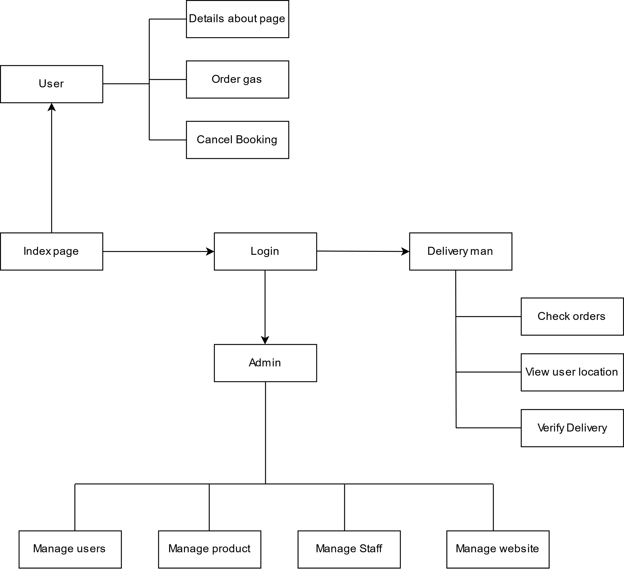

Fig 3.1: Block diagram of Hamro Gas

Every users are greeted with the index page where users can get the details about the system. Users can go on to book the required LPG gas of certain brand , complete the payment process and must fulfill the verification protocol send via mail. The admin can log in to the back end and access the information of every users. The admin can manage remaining stocks, booked details ,staff, users etc.

### 3.3 E-R Diagram

Fig 3.2 E-R diagram of Hamro Gas

### 3.4 Tools and Platforms

1. PHP
2. MySQL
3. CSS, Bootstrap
4. JavaScript
5. XAMPP
6. Sublime Text Editor

Platform: Windows

# CHAPTER 4

## RESULT AND DISCUSSION

### 4.1 Results and Features

This system displays information about the LPG gas of available company. Users can check the detail about the site and book the Gases and get them delivered. The agencies that will use this system is able to maintain the customers and booking details in systematic manner. The users can ask for the details and also complain in comment section if they are not satisfied with the services provided.

##### 4.1.1 Screenshots

###### 4.1.1.1 Frontend

###### 

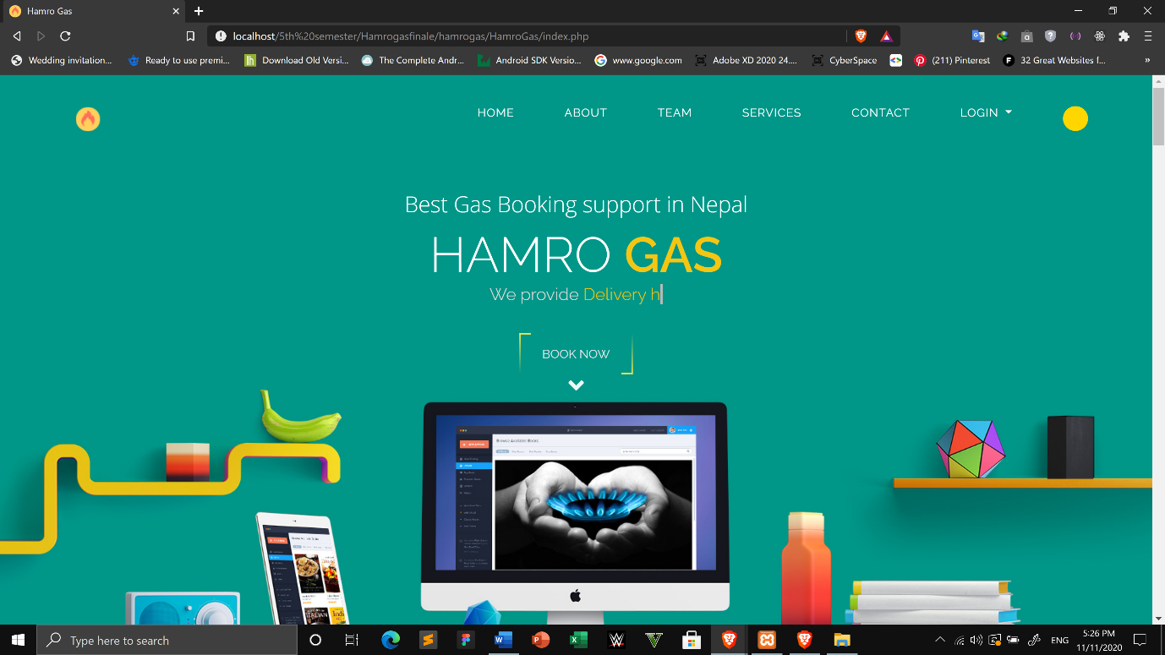

Fig 4.1: Index page

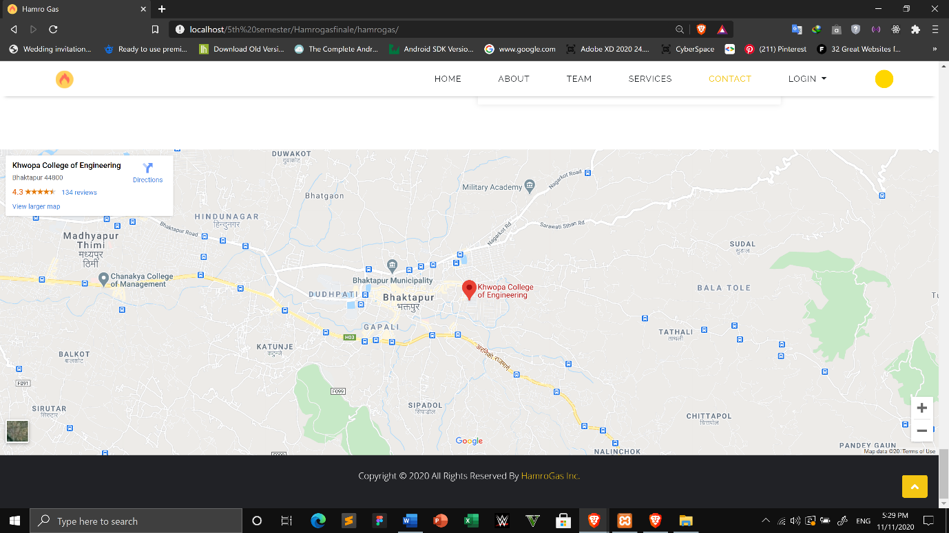

Fig 4.2: Google Map

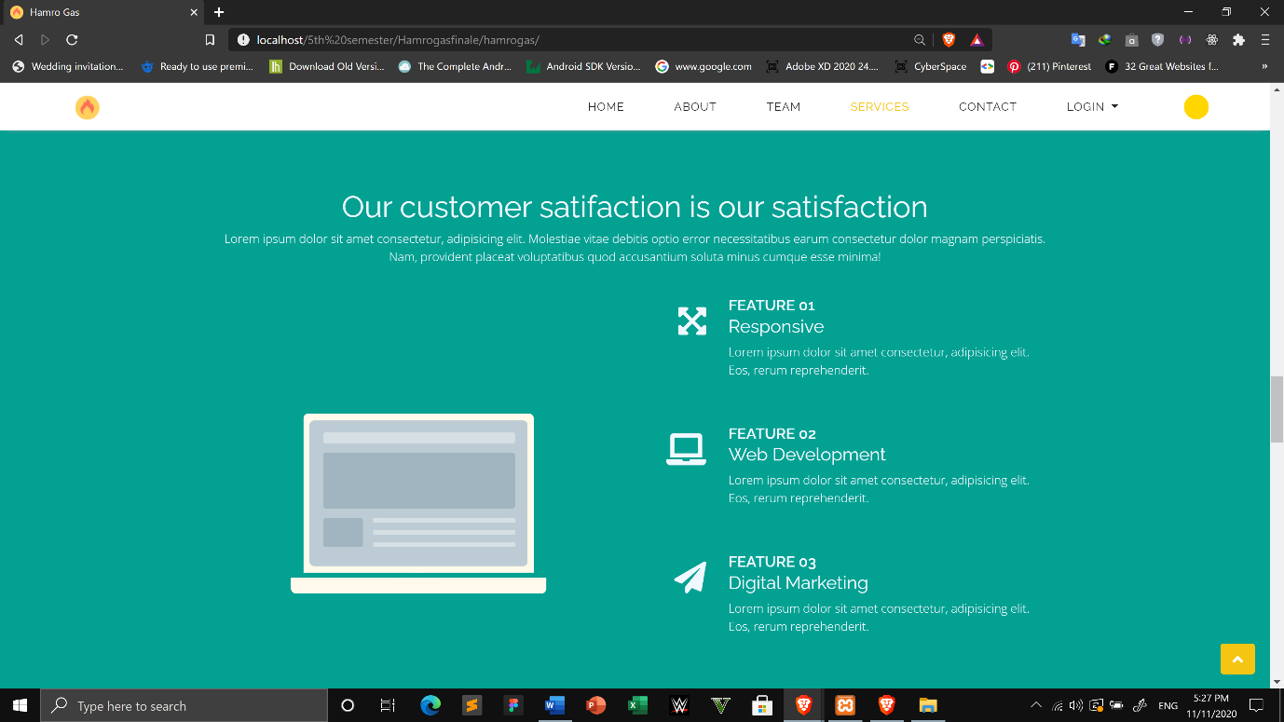

Fig 4.3: Banner page

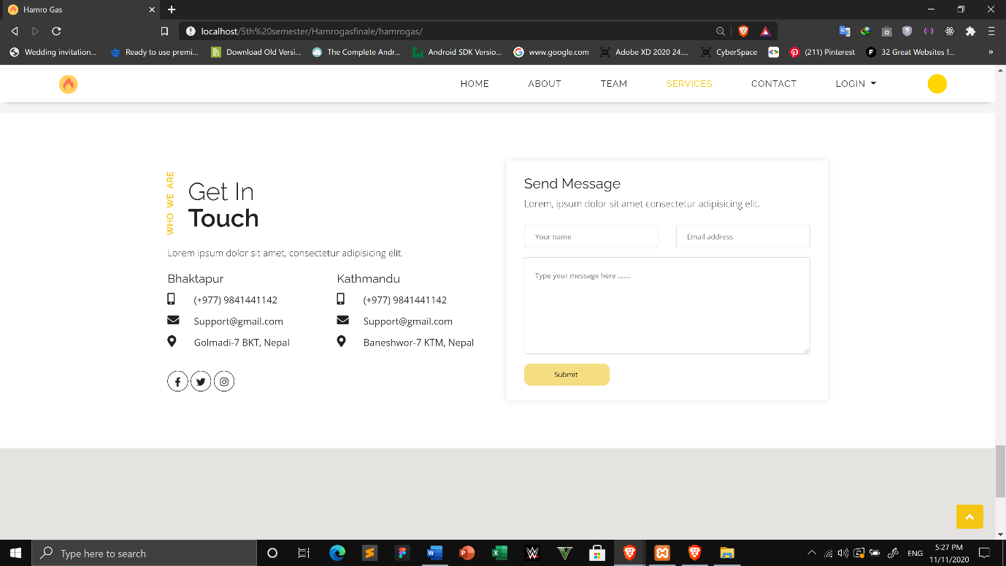 Fig 4.4: Contact page

This is the index page where we can login as an admin or delivery man.

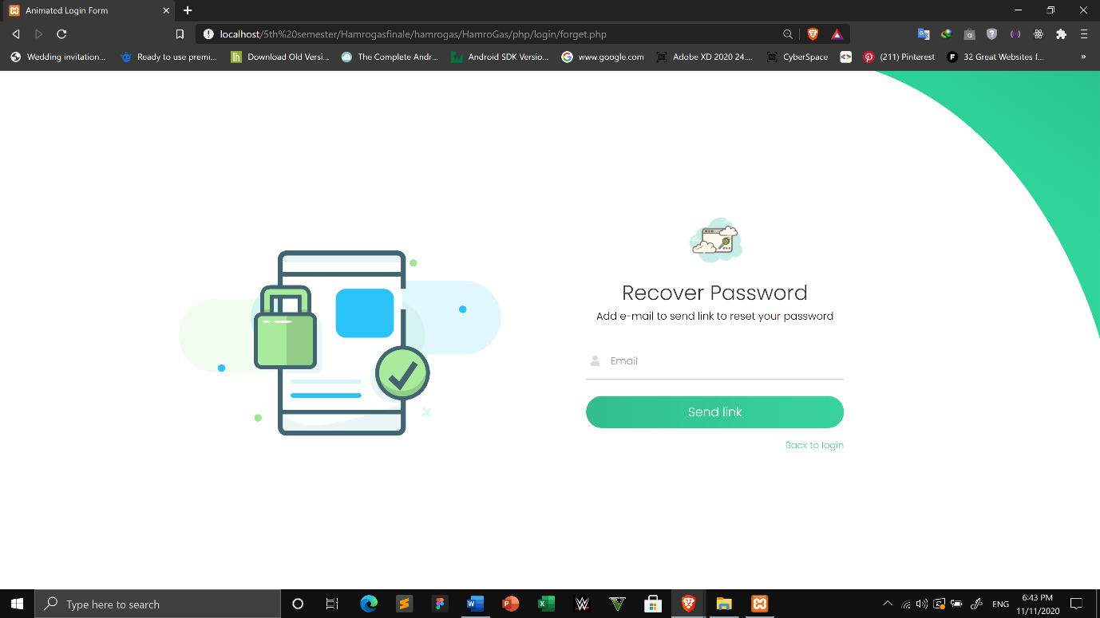

Fig 4.5 Recover password

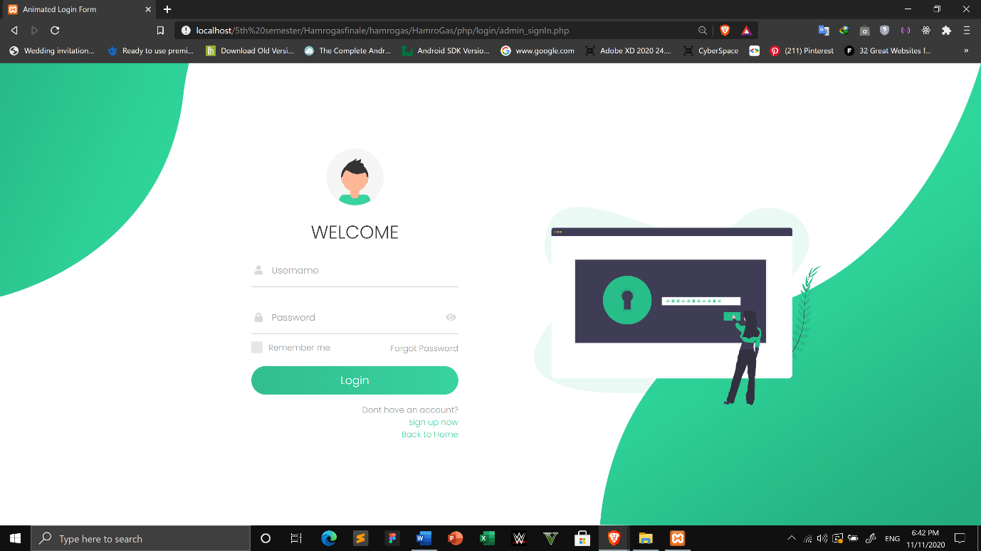

Fig 4.6: login page

This is a login page where we can login/sign in and recover password.

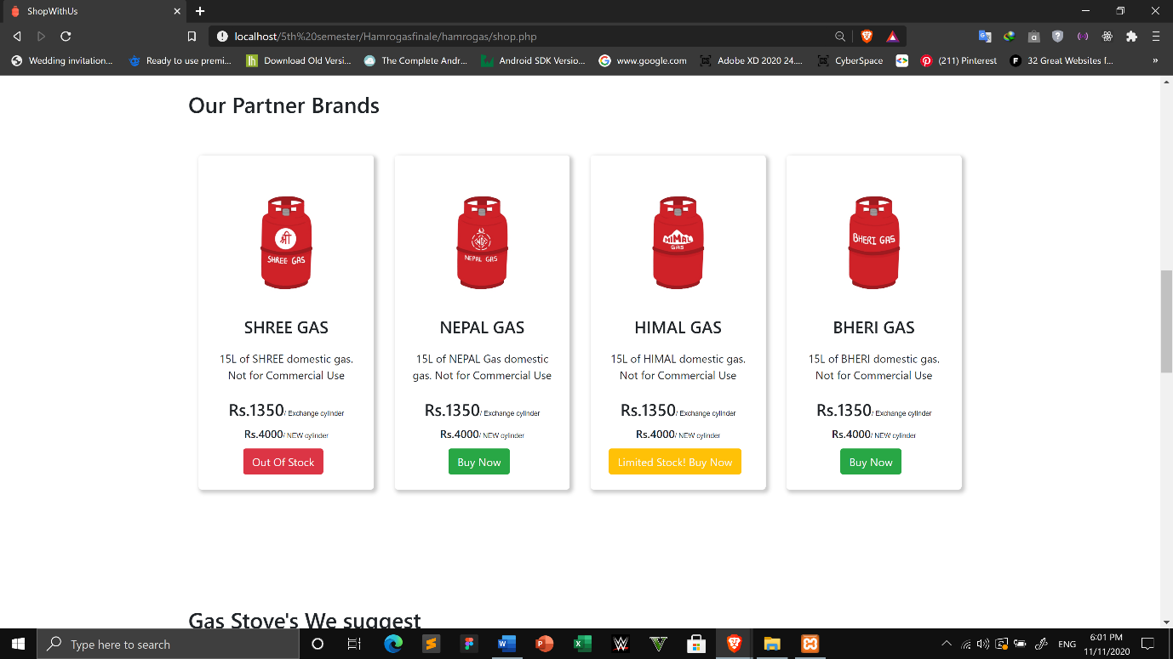

Fig 4.7: Gas Display

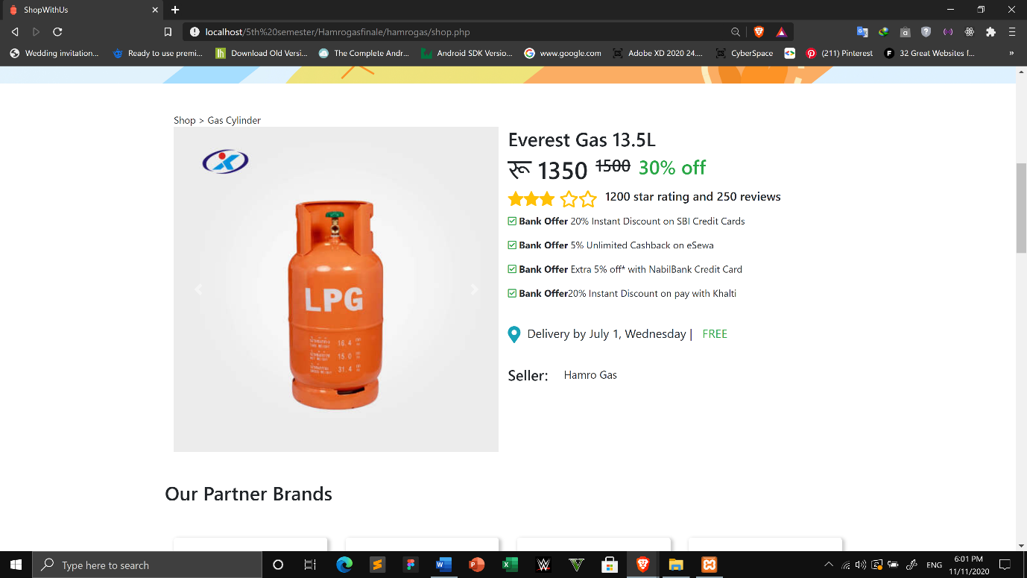

Fig 4.8: Gas description

This displays the gases, stove and the description of the gases.

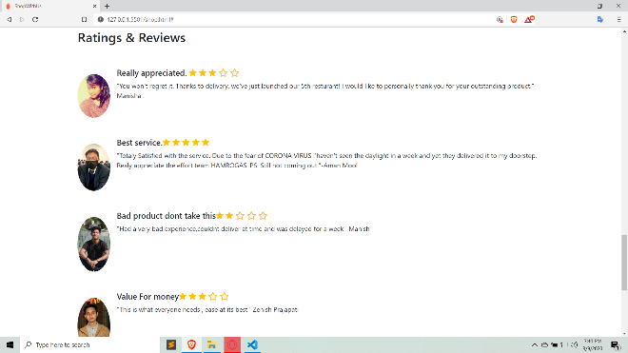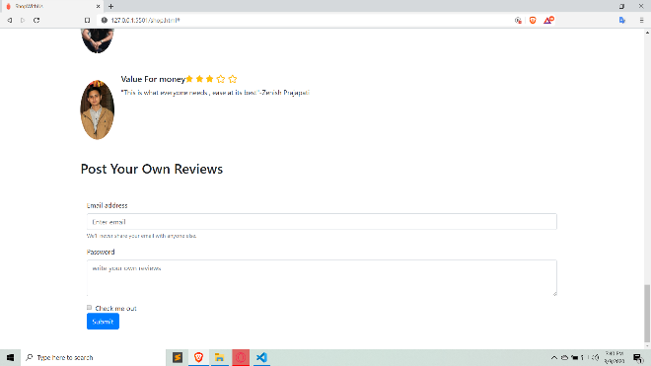

Fig 4.9: Review page

We can put reviews about the products.

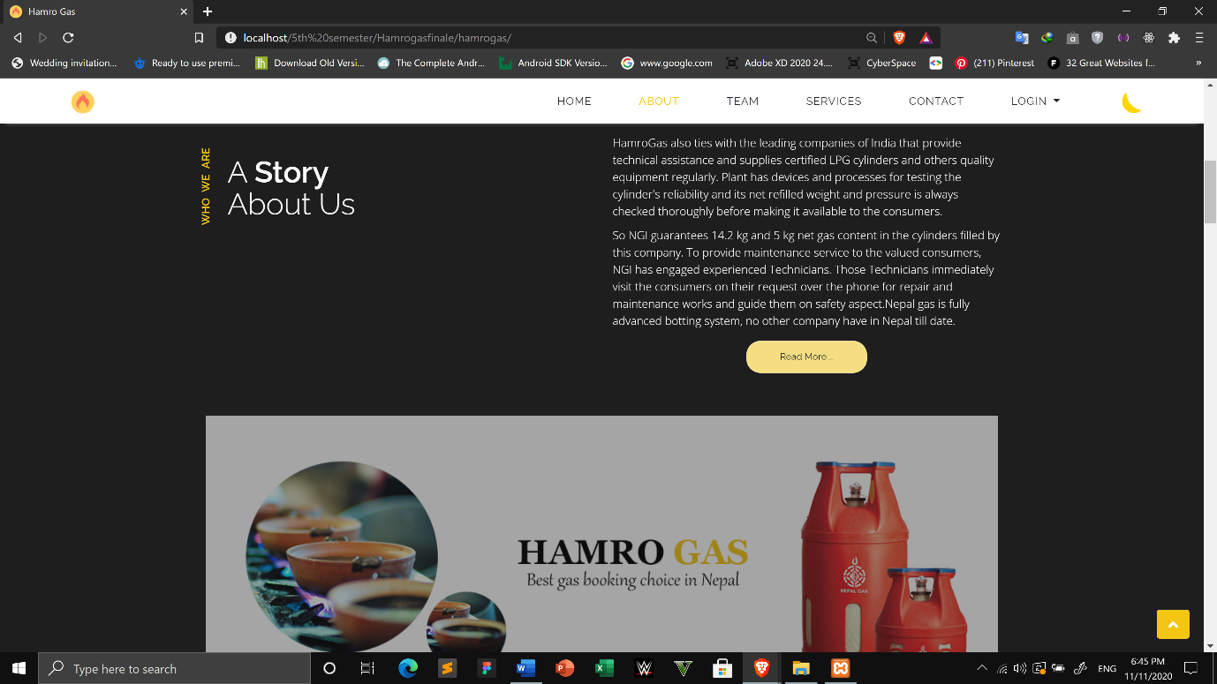

Fig 4.10: Dark mode

This is the dark mode feature of our website.

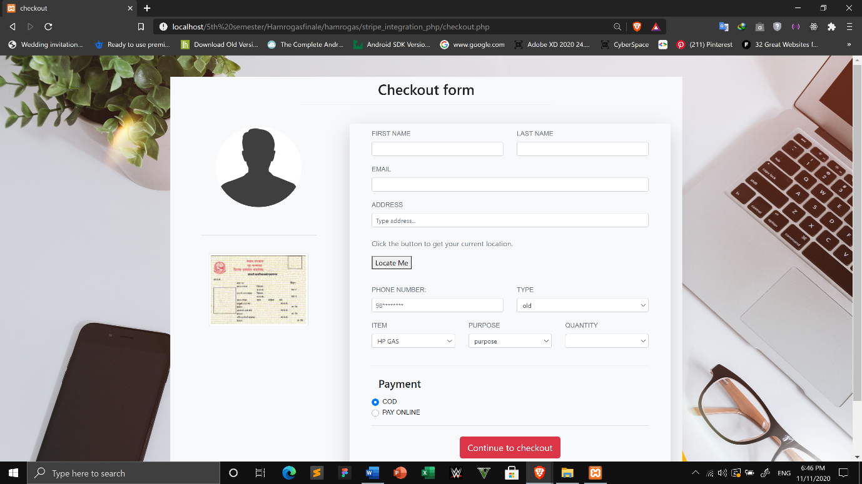

Fig 4.11: Checkout form

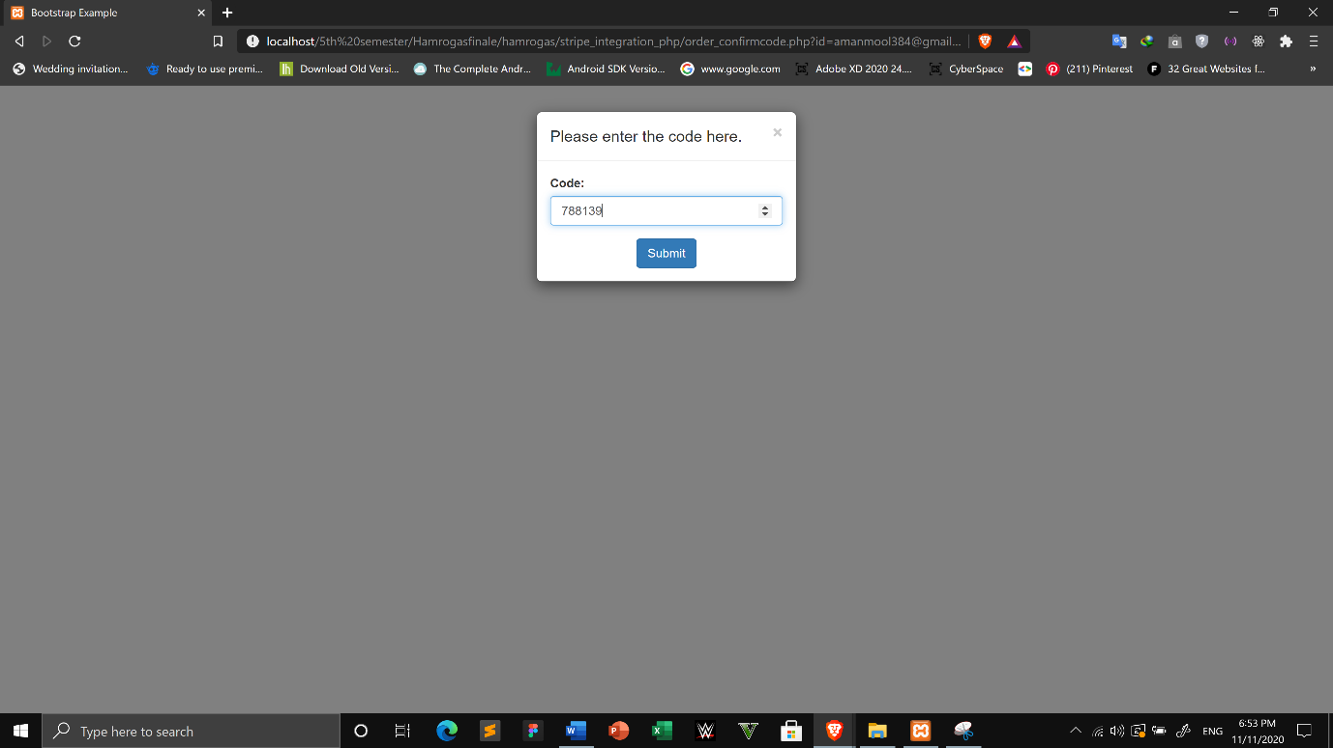

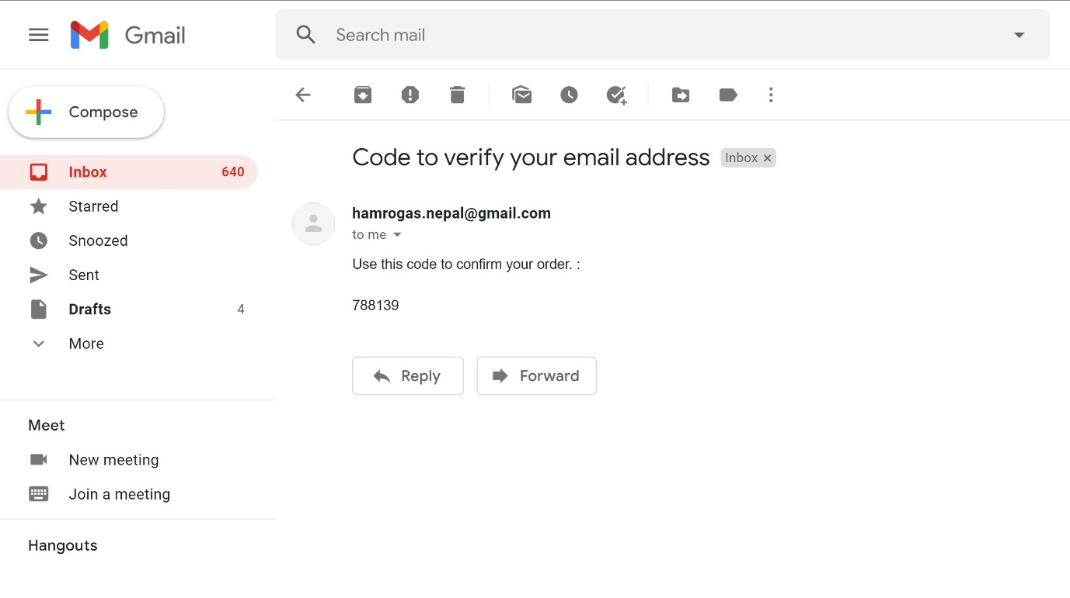

Fig 4.12: Verification code

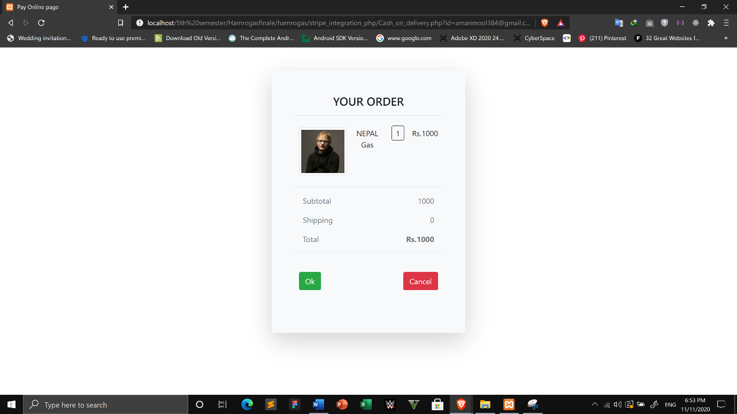

Fig 4.13: Shipping Details

###### 4.1.1.4 Backend

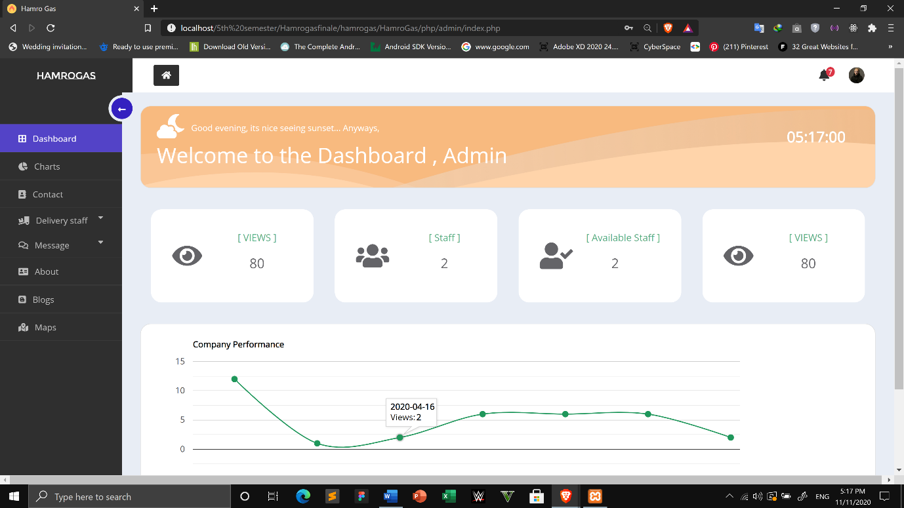

Fig 4.14: Dashboard

# 

Fig 4.15: Charts

# 

Fig 4.16: Add delivery staff

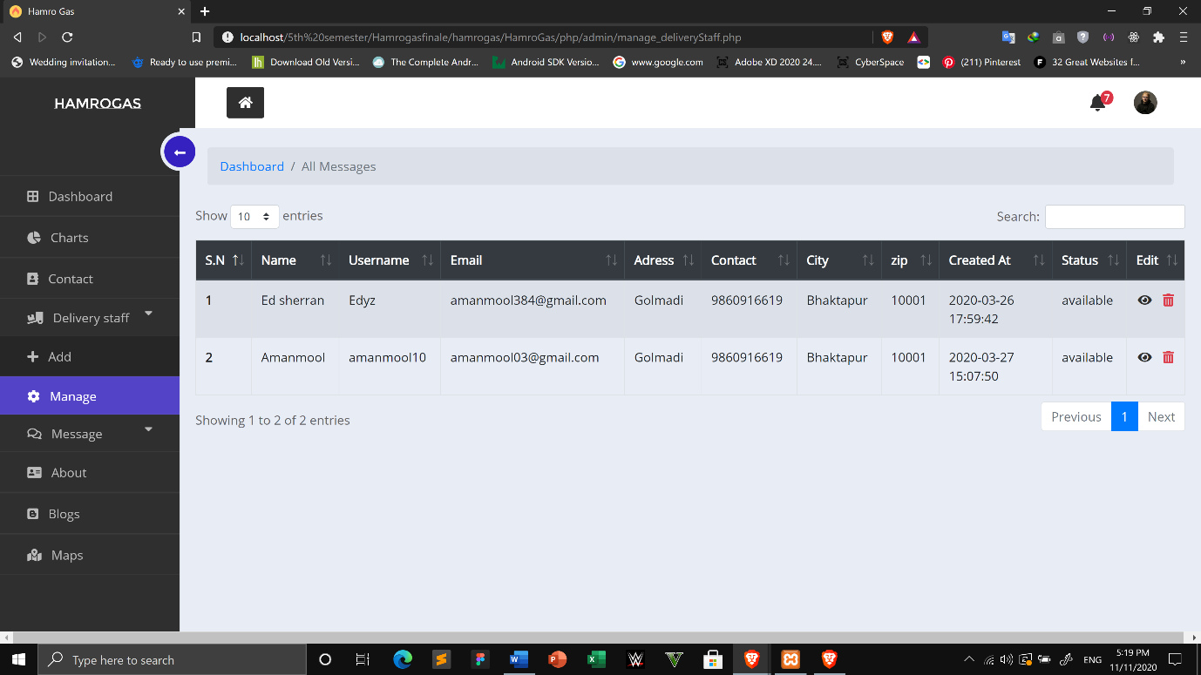

Fig 4.17: Manage delivery staff

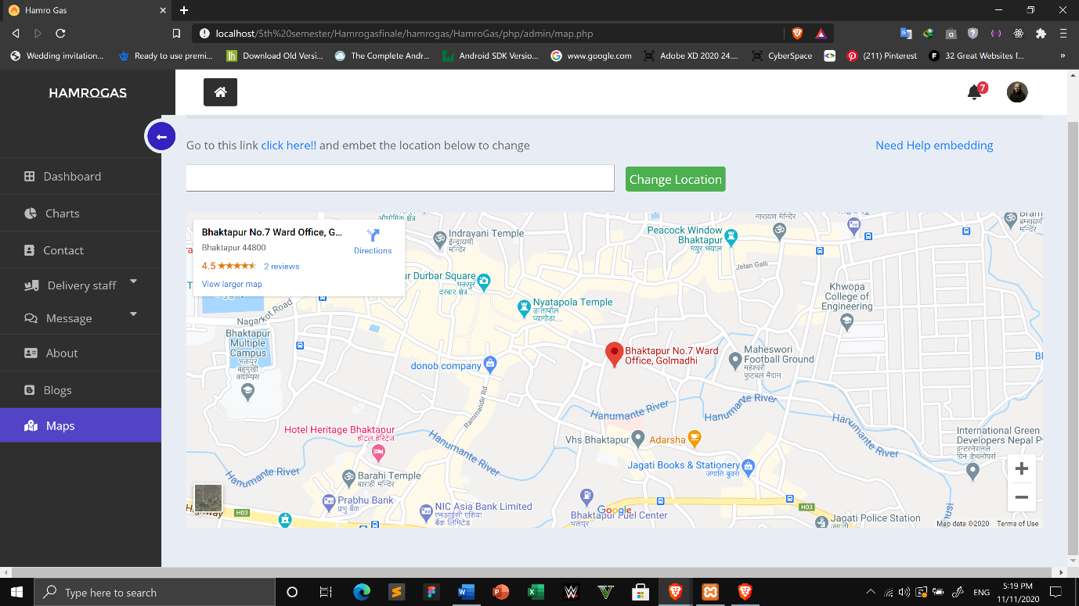

Fig 4.18: Manage Map

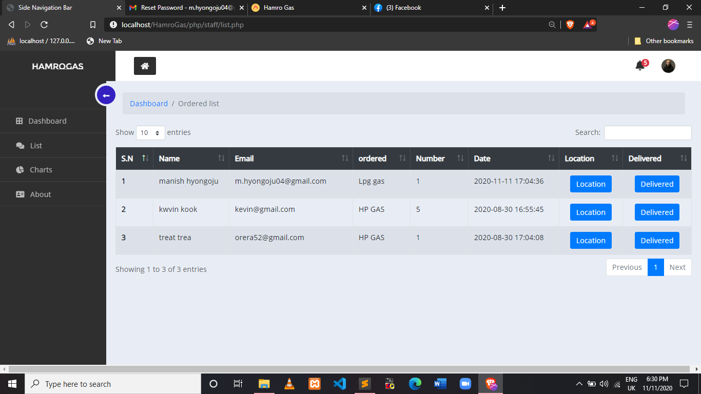

Fig 4.19: List of orders

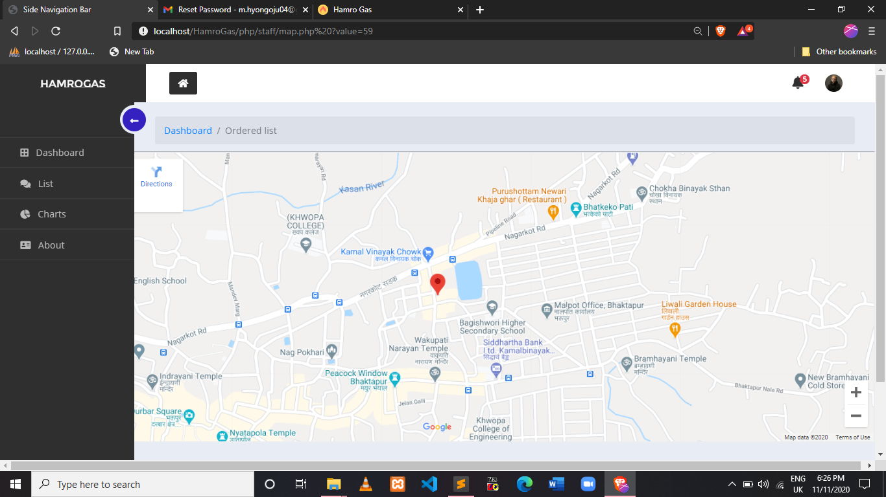

Fig 4.20: Delivery Location map

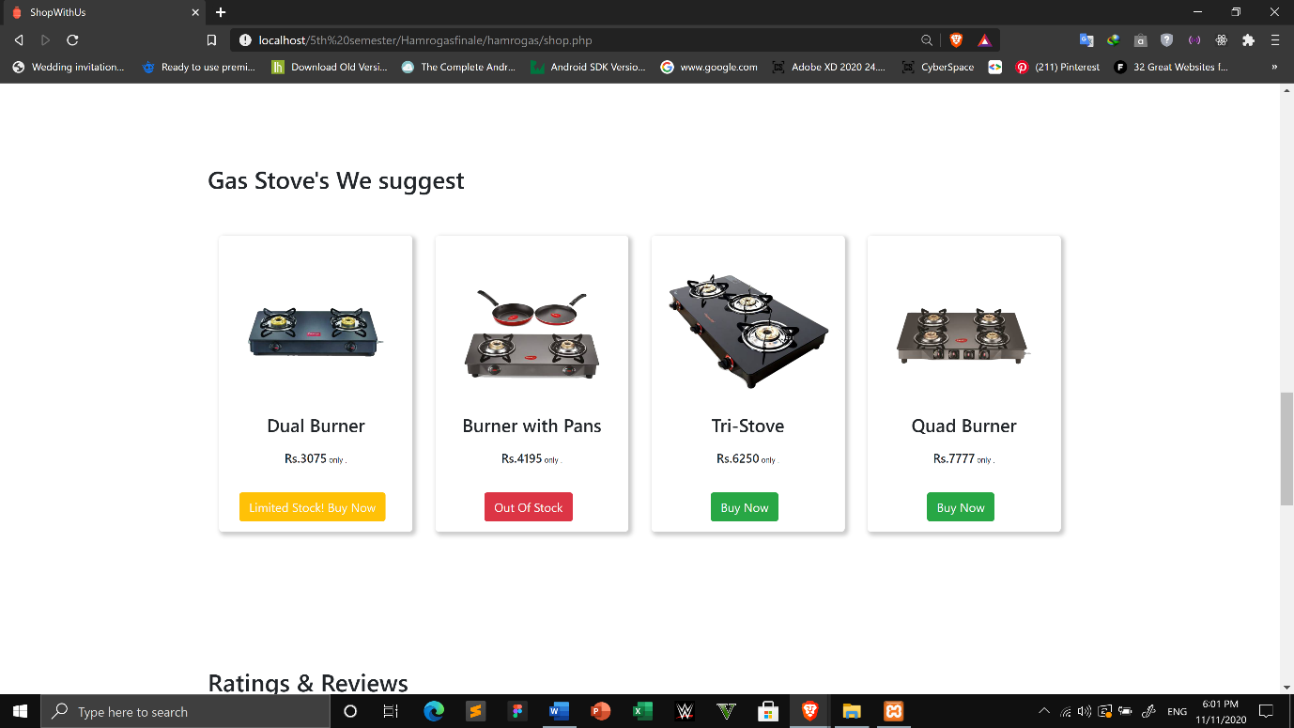

Fig 4.21: List of Stoves

# CHAPTER 5

## CONCLUSION AND RECOMMENDATION

### 5.1 Conclusion

We developed **“Hamro Gas”** as our academic project. As there are many other projects but we designed this project for the purpose helping users book the desired company gases in advance and get gases delivered.

### 5.2 Future Recommendation

In this project some improvements can also be done. Some of the future recommendation to make this project more qualitative are as follows:

* Location tracking while gas being delivered can be included.
* Design of site can be improved.
* Auto booking of Gases ever month could be included.

# REFERENCES

[1] “Nepal Gas”, www.nepalgas.com.np/page/services [10/12/2019]

[2] “BharatGas”, www. ebharatgas.com/bharatgas/LPGServices/Index [11/12/2019]

[3] “pickNdrop”, https://www.pickndropnepal.com/[11/9/2020]